Functions for Sediment Entrainment

by Kaveh Zamani and Fabián A. Bombardelli
Department of Civil and Environmental Engineering, University of California, Davis.

Background

Under appropriate simplifying assumptions, the one dimensional St. Venant shallow water equation takes the form:

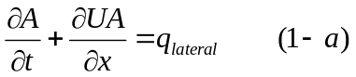

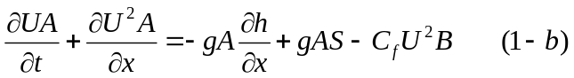

where

t=time;

x= boundary-attached (bed attached) streamwise coordinate

g=gravitational acceleration

S= bed slope which is given

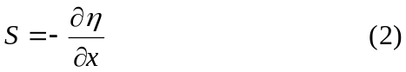

C_{f} = bed friction coefficient

The river assumed to carry a dilute suspension of sediment. An approximate form of depth averaged conservation of suspended sediment is as follows:

where

v_{s}= is the sediment fall velocity (Appendix B)

E_{r}= sediment entrainment rate

E_{s}= dimensionless rate of entrainment of bed sediment into suspension, E_{s}≡ E_{r} / v_{s}

D_{r}= volume rate of deposition per unit time per unit width.

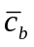= near bed value of 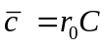
In the steady, uniform turbulent flow over a flat bed the net vertical flux (F_{sz}) of sediment just above the bed is given by:

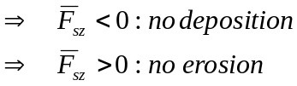

If equilibrium steady uniform suspension rate exists, there is no net normal flux of suspended sediment at the bed.
The equilibrium condition yields 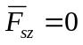

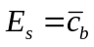 hence the entrainment rate will be given by .
There are many formulas for concentration sources near bed, the following formulas were selected from the books by eminent researchers of sediment transport:

1-“Sedimentation Engineering”, Marcelo H. Garcia, ASCE 2008.

2-“Erosion and Sedimentation”, Pierre Y. Julien, Cambridge University Press 1998.

3-“Principle of Sediment Transport in Rivers, Estuaries, and Coastal Seas”, Leo C. van Rijn, AQUA Publications 1993.

4-“Estuarine and Coastal Fine Sediment Dynamics” J.P.Y Maa, L.P. Sanford, and D.H. Schoellhamer, Elsevier 2007.

Entrainment formulas

Garcia and Parker

In 1991 Garcia and Parker suggest the following formula:
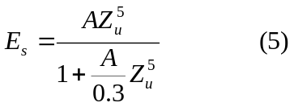
E_{s}= Sediment entrainment coefficient
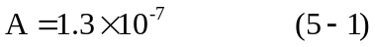
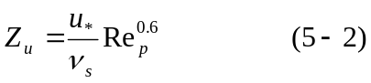
Z_{u} is a measure of the strength of shear stress but it also takes into account the particle size. Here reference level is taken to be 5% of the depth
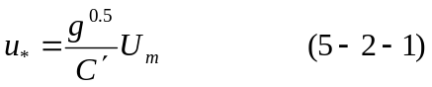
u* : shear velocity
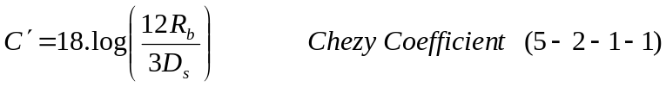
U_{m}= is the cross sectional flow velocity
R_{b}= Hydraulic radius of channel
v_{s}= sediment fall velocity (see the Appendix B)
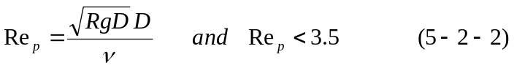
Re_{p} is particle Reynolds number

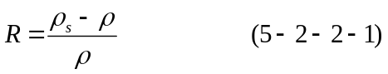

R is specific submerged gravity (1.65 for quartz particle)
g = Gravitational acceleration
D = D₅₀

In Garcia and Parker (1991) a comparison of many of other entrainment formula could be found. They have found that the relation (5) works well for fine-grained non-cohesive sediments.

van Rijn

Another formula that has been found to perform well is that of van Rijn (1984b)

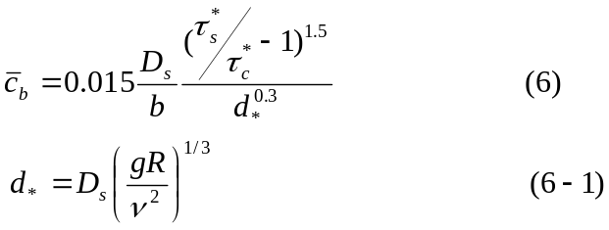

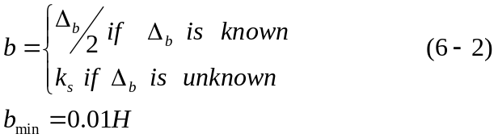

k_{s}=3D for uniform material (is effective roughness height)
Δ is a bed forms height and b=k_{s} when bed forms height is unknown
H=Total depth of flow

d*= is dimensionless particle parameter
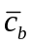: Reference concentration for equilibrium case (near bed value of mean volumetric sediment concentration)
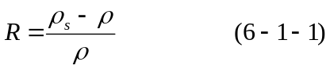
D_{s}= D₅₀
g = Gravitational acceleration
Note: here 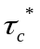denotes the dimensionless Shields stress due to skin friction
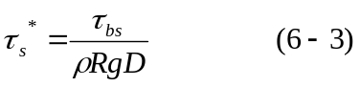
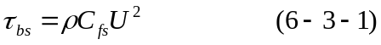
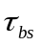 is the shear stress caused by skin friction
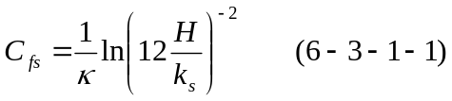
C_{fs} is the resistant coefficient
k_{s} is the effective roughness height
= von Karman constant (0.41)
This formula has been used extensively in numerical treatment of suspended sediment transport (Duan et al. 2001; Zeng et al. 2006)

Smith and McLean

Third equation which performs well is by Smith and McLean (1977). This equation is based on Yalin early works (1963).

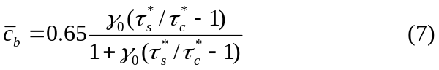
where
: Reference concentration for equilibrium case
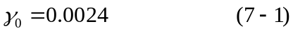

The value of b (height in which the 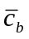is to be evaluated) is given by the following
k_{s}= is the equivalent roughness height for fixed bed

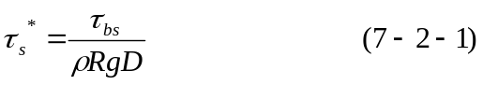
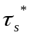is the dimensionless stress due to skin friction

is the shear stress caused by skin friction
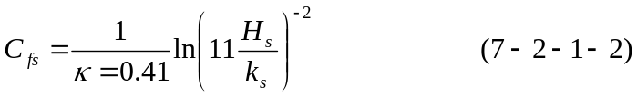

Here H_{s} is the depth in absence of bed forms (H_{s}+H_{f}=H) and H_{s} it could be expressed as:

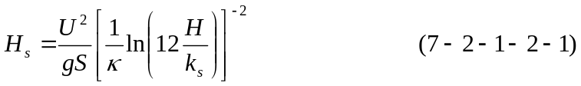

= von Karman constant (0.41)
K_{s} is the effective roughness height
S=energy slope

is dimensionless critical Shields shear stress for incipient motion (Appendix A)
The Smith and McLean formula is used extensively in benthic boundary layer flows and oceanic sedimentation (McCave 2004)

Zyserman and Fredsoe

After the comparative analysis of different entrainment formulations, in 1994 Zyserman and Fredsoe proposed an empirical relation (8) using the Fort Collins experimental data

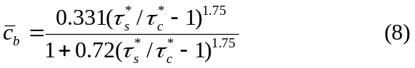
here is referred to concentration at b=2D₅₀
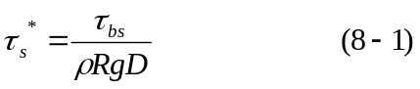
is the shields stress due to skin friction

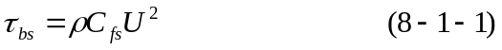
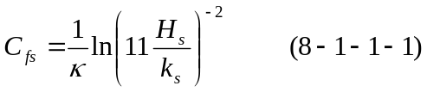
Here H_{s} is the depth in absence of bed forms, (H_{s}+H_{f}=H) and H_{s} could be expressed as:
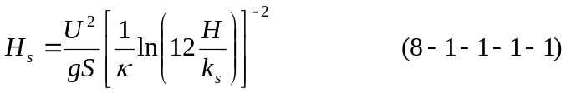
= von Karman constant (0.41)
S=energy slope
k_{s} is the effective roughness height

is dimensionless critical Shields shear stress for incipient motion
This formula is based on laboratory data, but it has been used widely in costal engineering practice (Soulsby 1997).

- Appendix A: Fitted Formula to the Shields Diagram

A-1: Brownlie (1981)
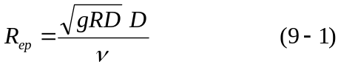
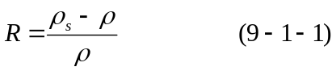
D= D₅₀
g = Gravitational acceleration
ν= kinematic viscosity of water
is dimensionless critical Shields shear stress for incipient motion
Re_{p} is particle Reynolds number

A-2: Mantz (1977)
For fine-grained sediments Shields diagram does not provide realistic results. Mantz conducted a series of experiments and observed that for fine grained non-cohesive sediments the critical shear stresses can be estimated with the following relation

The Mantz equation merges Brownlie equation for R_{ep}=4.22

- Appendix B: Fall Velocity of non-cohesive sediments

Fall velocity or settling velocity is a fundamental property of a sediment particle. Falling under the gravity action a particle will reach a constant, terminal velocity once the drag is equal to the submerged weight of the particle. The range of particle sizes can be categorized in three following sizes:

a) Medium and coarse Sand, Gravel, Cobble, and Boulder; d_{s}>0.1 mm which must be calculated with Rubey’s approximation of fall velocity (Stokes’ law is not valid) b) Very fine Sand and Silt; 0.1 mm >d_{s} > 0.004 mm which can calculated by Stokes’ law
c) Clay; which is also calculated by Stokes’ law but flocculation is possible

Stokes’ law:

It is valid for small particle size (d_{s}<0.1 mm) falling in viscous fluid (Re_{p}<0.1)
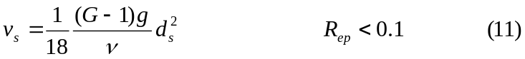

G is specific gravity and,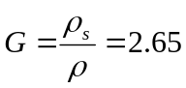 for quartz particle.

Rubey’s Formula:
Rubey’s approximation formula (13) of fall velocity in clear water is based on drag coefficient of sand particle equation (12):

C_{D} is the drag coefficient
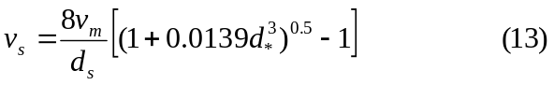
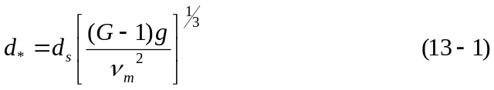
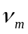 is the kinematic viscosity of water-sediment mixture.
d* is the dimensionless particle diameter

Table 1: Comparison of settling velocity of different sediment classes with stokes’s and Rubey’s formula
Sediment Class | Diameter(m) | Stokes’ Vs (m/s) | Reynolds Number | d * | Rubey Vs (m/s) | Governing Eqn | Diffrence (%)
Very fine silt | 6.00E-06 | 3.24E-05 | 1.95E-04 | 1.52E-01 | 3.25E-05 | Stokes | 0.283
Medium silt | 2.35E-05 | 4.97E-04 | 1.17E-02 | 5.95E-01 | 4.98E-04 | Stokes | 0.211
Very fine sand | 9.00E-05 | 7.29E-03 | 6.57E-01 | 2.28E+00 | 7.04E-03 | Stokes | 3.533
Fine sand | 1.80E-04 | 2.92E-02 | 5.25E+00 | 4.56E+00 | 2.32E-02 | Rubey | 20.474
Medium sand | 3.75E-04 | 1.27E-01 | 4.75E+01 | 9.50E+00 | 5.53E-02 | Rubey | 56.327
Medium gravel | 1.20E-02 | 1.30E+02 | 1.56E+06 | 3.04E+02 | 4.16E-01 | Rubey | 99.679
Small cobble | 9.60E-02 | 8.30E+03 | 7.97E+08 | 2.43E+03 | 1.18E+00 | Rubey | 99.985
Medium boulder | 7.68E-01 | 5.31E+05 | 4.08E+11 | 1.94E+04 | 3.33E+00 | Rubey | 99.999
As it is shown in the Table (1) both Rubey’s and Stokes’ formula yield practically same results for the cases of Reynolds numbers less than one, so all the settling velocities will be calculated base on Rubey’s approximation.

- Appendix C: Approximate physical prosperities of water at atmospheric pressure

Table2: Approximate physical prosperities of clear water at atmospheric pressure
Temp. (ºC) | Density  ρ (kg/m³) | Specific weight γ  (N/m³) | Dynamic viscosity μ (N.s/m²) | Kinematic viscosity ν (m²/s)
0 | 1,000 | 9,810 | 1.79×10⁻³ | 1.79×10⁻⁶
5 | 1,000 | 9,810 | 1.51×10⁻³ | 1.51×10⁻⁶
10 | 1,000 | 9,810 | 1.31×10⁻³ | 1.31×10⁻⁶
15 | 999 | 9,800 | 1.14×10⁻³ | 1.14×10⁻⁶
20 | 998 | 9,790 | 1.00×10⁻³ | 1.00×10⁻⁶
25 | 997 | 9,781 | 8.91×10⁻⁴ | 8.94×10⁻⁷
30 | 996 | 9,771 | 7.97×10⁻⁴ | 8.00×10⁻⁷

Also the change in the kinematic viscosity of water “ν” with temperature in degree Celsius can be roughly estimated from relation (14):

Miller and Poisson (1981) suggested the following equation of state for water density and salinity and temperature:
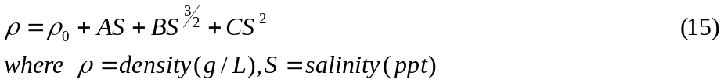
Jha and Bombardelli (2010) have shown that when the maximum volumetric concentration of sediment is less than 0.01 models developed for dilute flows work well and there is no need for corrections and any further assumptions. For flows having higher volumetric concentrations, inter-particle collisions become important and non-dilute models are necessary. Their results suggest a new limit for non-dilute flows between 2 and 5%. It is observed that the drag and virtual mass forces become important in the simulation of non-dilute flows. Also Woo et al. (1988) argued that when 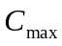> 0.04, the models developed for dilute flows do not work. Hence in cases with <0.02 it will be a rational to use dilute flow formulation.

Fine grained sediment transport
Fine grained sediment transport is generally characterized by size composition, and plasticity. Cohesion is due to electrochemical forces acting on the particle surface. Hence the degree of cohesion depends on the ratio of particle surface area to particle weight, that is, specific surface area. Migniot (1968) showed ratio of particle settling velocity to particle size increases due to floc and cohesion.
A characteristic gauge of clay mineral cohesion is cation exchange capacity (CEC). The higher the CEC the greater the cohesion, which causes micro-meter-sized individual clay particles to coagulate or flocculate, in water to form much larger aggregates, or flocs when water salinity exceeds a critical value which depends on the clay mineral.
Kaolinite, Illite, Chlorite , and montmorillonite are the most commonly found clays, in San Francisco Bay estuary Chlorite were found (Krone 1962). As salinity increases above the critical value, floc size density, and strength vary. However, above a salinity of about 10 ppt, its effect on the floc properties is comparatively minor (Krone 1962; 1986) and there is no need to take it into calculation.

Table 2: Clay Minerals. CEC, and Critical Salinity for Flocculation
Clay mineral | Nominal  Diameter (μm) | CEC  (meq/100 g) | Critical Salinity  (ppt)
Kaolinite | 0.36 | 3-15 | 0.6
Illite | 0.062 | 10-40 | 1.1
Chlorite | 0.062 | 24-35 | Not reported
Montmorillonite | 0.011 | 80-150 | 2.4

To make assessing of transport related data possible, the basic parameters of floc in cohesive sediment should be defined. Regarding the fact that the cost of evaluation of a large number of parameters is not feasible in most technical studies, finally six parameters have been chosen to be representative of characterization of sediment in the situation in which the transport is not overwhelmingly influenced by biochemical factors;

Particle size: use the standard procedure of (ASTM 1993d), settling column bottom withdrawal test. If the organic content is greater than 10%, this test shouldn’t perform
Fall or settling velocity
Mineral decomposition: obtain types of relative quantities of the principle clay and non-clay minerals using standard X-ray diffraction tests.
Organic content: Loss of sample mass on ignition standard test (ASTM 1993d)
An alternative is to measure total organic carbon.
Cation exchange capacity: follows standard procedure for clay minerals (ASTM 1993c, SCS 1992)
Salinity: report salinity if less than about 10 ppt, At higher salinity the effect of salinity on floc structure is comparatively minor.

Settling velocity of cohesive sediment
For hindered settling of mud flocs, Mehta (1986) suggested a modified for of the well known Richardson and Zaki formula
where v_{s} is the effective settling velocity, v_{s,0} the settling velocity of a single particle in still water, k is an empirical parameter, φ_{p} is volumetric concentration of primary particle, φ_{p}= C/ρ_{s} in which C is the mass concentration and ρ_{s} the density of the sediment.
Winterwerp (2002) reasoned that the rational embedded in(16) can be applied to cohesive sediments as well. He suggested that, as each individual floc within a suspension is considered to settle in the rest of the suspension, this would result in three hindering effects:
- Return flow and wake formation. A settling particle generates a return flow and a wake. Other neighboring particles will be influenced by this and their effective settling velocity will be decreased by a factor (1- φ), where φ is the volumetric concentration of flocs.
- Viscosity. Each individual particle within a suspension is considered to fall in the remainder of that suspension which has an increased viscosity.
- Buoyancy or reduced gravity. For the same argument, an individual particle settles in a suspension with an increased bulk density. The effective settling velocity is decreased by a factor of (1-φ_{p}).
This led to a new theoretically derived formula for the hindered settling of mud flocs:
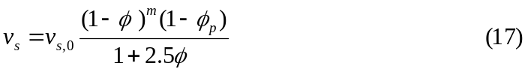
where v_{s} is the effective settling velocity, v_{s,0} the settling velocity of a single particle in still water. The volumetric concentration is herein related to the gelling concentration (≡ C/C_{gel}), in which C_{gel} is the concentration at which flocs become space-filling and form a network structure, called a gel, and a measurable strength build up. The volumetric concentration of primary particles is also related to the gelling concentration, 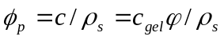
Here the 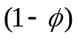accounts for the return-flow effect, 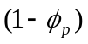accounts for the buoyancy effect and 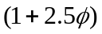accounts for augmented viscosity. The exponent “m” is an empirical parameter to account for possible non-linear effects. When the return flow effect is linear (m=1) only the volume effect of a suspension settling in a liquid is taken into account. The downward flux of sediment is thus expected to create an equal upward flux of water with sediment. When nonlinearity is taken into account, all the effects generated by a settling particle in a suspension are incorporated.
Winterwerp (2002) compared Eqn. (17) to data by fitting the model parameter and not actually using parameter values derived from data. A reasonable fit was obtained.

